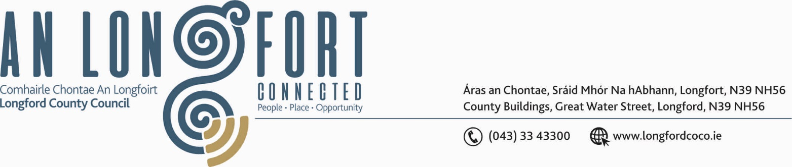

LONGFORD MUNICIPAL DISTRICT

Please note Meeting will be held using Microsoft Teams.

Please note Time of Meeting – 2.00 p.m.

16th April 2020.

To: Each Member of Longford Municipal District.

Dear Member,

You are requested to attend Meeting of Longford Municipal District to be, held using Microsoft Teams, on Wednesday, 22nd April 2020 at 2.00 p.m. to transact business, as set out on the Agenda hereunder.


Yours sincerely,

_______________
Anne Lee,
Meetings Administrator.

AGENDA

Prayer before meeting.

- Confirmation of Minutes of the meetings of Longford Municipal District held on
the 3rd April 2020 - enclosed.

- Matters arising from Minutes.

- Declaration of Interest by Members.

- Management Report - enclosed.

- 2020 Cathaoirleachs Award.

- Fix date for Longford MD 2020 Annual Meeting

- Notices of Motions, submitted by Councillors, as listed hereunder –

Councillor Gerry Warnock.

“I am calling on Longford Municipal District to commission a Flood Risk Assessment of Longford Town with a view to preparing a Works Programme to help protect homes and businesses against the risk of future flooding similar to what was experienced in the wake of Storm Denis.”

Councillor Gerry Hagan.

“In the interest of public safety, I call on Longford Municipal Council to extend and complete the footpath along the Athlone Road at Stonepark and insert ducting for lights before completion.”

“To carry out works to alleviate the ongoing flooding problem at the crossroads in Cullyfad Village.”

- A.O.B.



